**ANALYST FROM CASE**

**AND REAL EXPERIENCE**

**What does “Analyst from case” mean?**

This is common usage in business when the researchers put their own case to analyst the market needs and wants. Using this technique, the research has to be the one who really understand and has been in that market for a long period of time.

As Paul Graham said:”Successful startup is the startup which makes something people want/need”. And, the best way to find what people want/need is put ourselves into customer’s case.

**Scenario**

Yesterday, I want to use eCommerce to surprise my 6 years old brother and the only way for me to do it is through big and reliable B2C marketplace like Lazada.vn or Adayroi.com. I want to pay online through my visa card and let them deliver to my house under my dad’s order.

**Action**

I went across Adayroi, the products and items they have is not as diversed as Lazada. However, it is normal because they just launched a few days ago and still a beta version. Lazada has been in VN market the last 4 years so they have more sellers/items; however, not really much different. I wanted to buy a toy for 6 years old kid, and I was kinda struggling because I dont know what should I search. If I put toy, it will give a lot of toys which he does not like. Finally, I searched for RC toys (Remote Control). On Adayroi, it popped up around 15 items which is RC and more than half of the page is electric fan with remote control, TV remote control. On Lazada, it is better in result. There were a lot of different RC toys for the result and the search engine knows that I am looking for toys; therefore, none of the fans or TV’s remotes popped up.

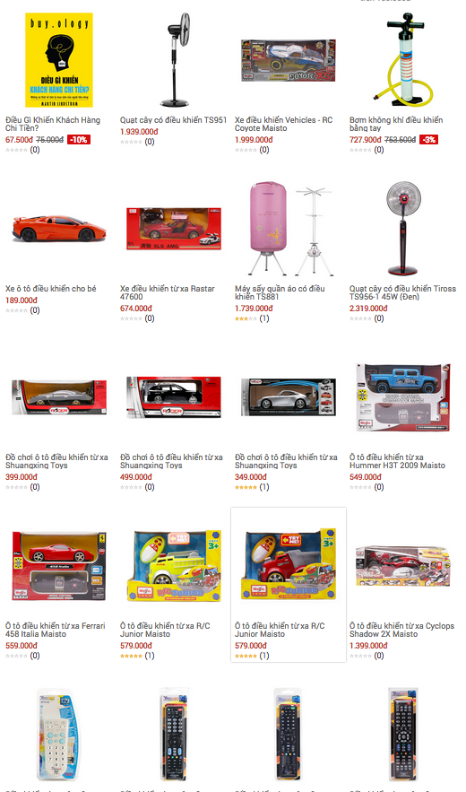

*Adayro’s search result, it is not as good as Lazada and it makes me want to leave the page. Way way worse than TaoBao*

**Result:**

I have decided to go with Lazada because they seems like have a lot of toys. I try to take a next level of searching by putting the name of the Toy I want. I put “robot remote control”. Right away, Lazada show me the kinda 90% of my expectation. A transforming robot with remote control. My brother gonna love this. I have decided to place an order regardless the price is around $40 USD (800k VND).

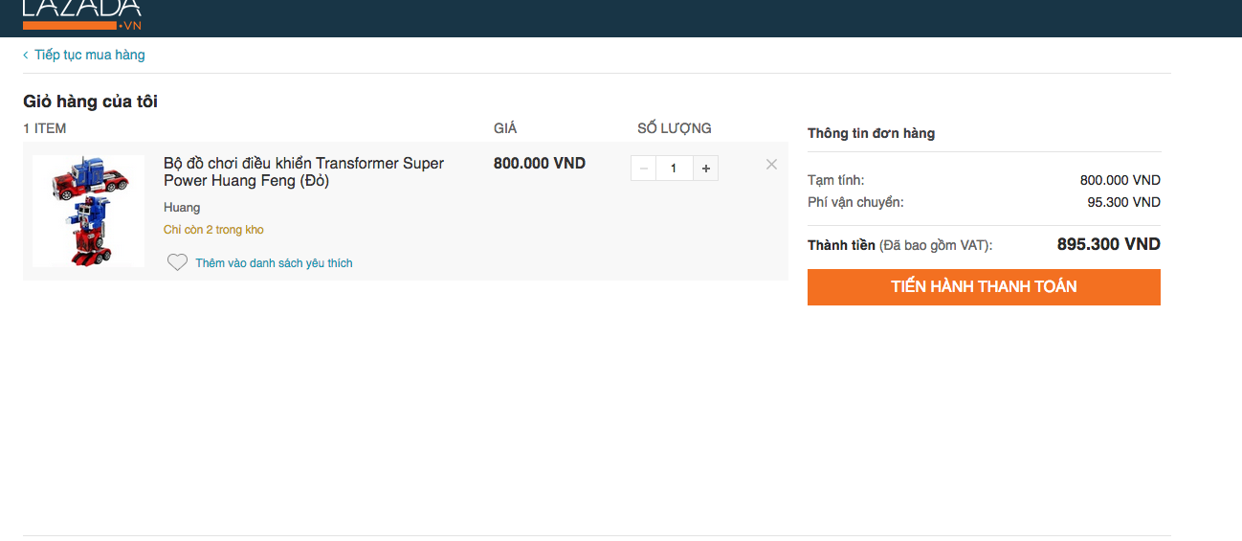

*This is the robot I am about to order.*

**Placing the order**

As I have said, the only way for me to buy is through Visa card eventhough Lazada has a lot of other options for payment methods like COD, Domestic ATM card, and even loan. COD can be cash at my house, but I want to pay this so I did not choose COD. The process of purchasing after I found the desired item is quite easy and simple. Standard shipping is around 3 days for the item to be at my house even I live right in the heart of Hochiminh city, district 1. And, it costs me an amzing amount of shipping fee, 95,300 VND which is around $5. It sounds like a small number in the U.S. However, in Vietnam, it is a different story. I was kinda rethink about it, with that much of money, i can even buy one more big toy at a local store. I was ended up without placing the order and asking my friend to help me buy something from local store.  
  
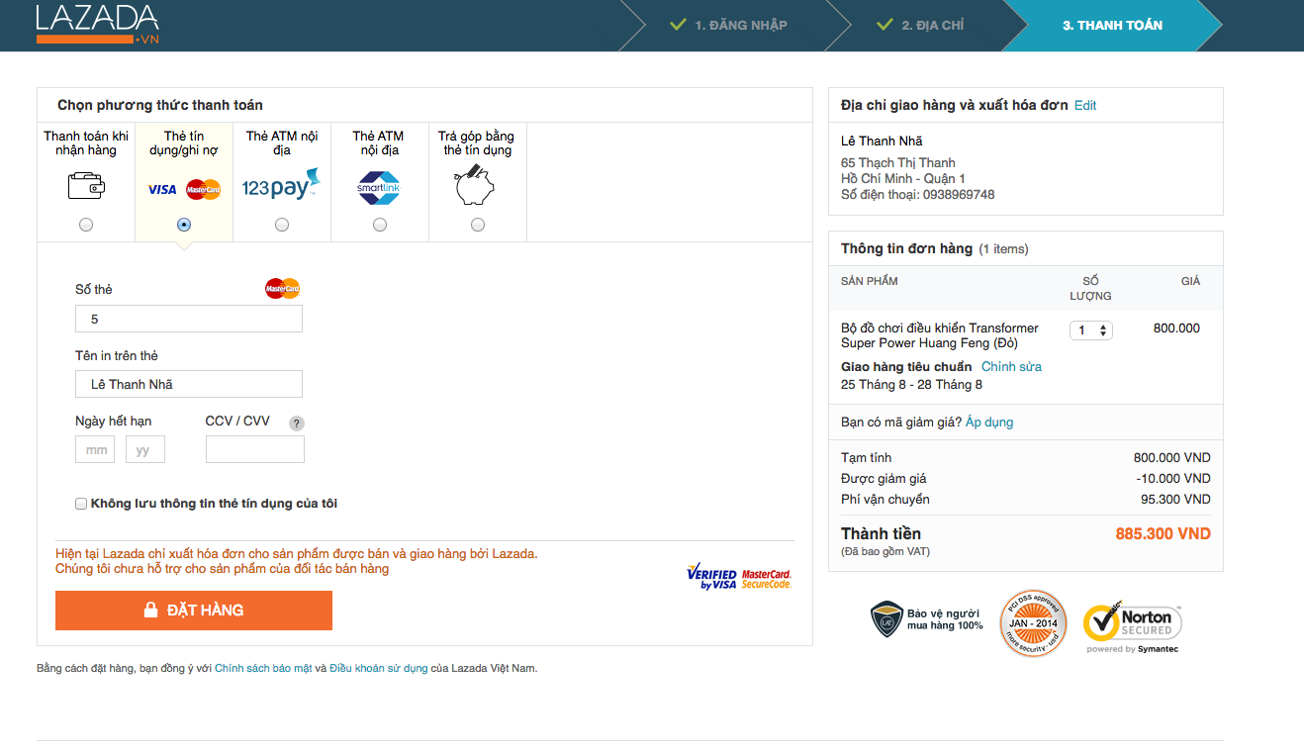  
*Lazada’s payment process and the shipping fee*

**Analyst**

**Why did I Lazada or Adayroi to search but not others like 5giay, vatgia, muahangnhanh?**

Obviously, there is no C2C marketplace can help me to do this except if there is something like TaoBao in Vietnam. Also, because of nobody sell toys online except B2C and if there is one, how can I pay? I don’t want to pay by transfering from my bank account to other’s bank account, and what if they don’t really sell after I paid? Therefore, B2C is the best way for this. There are more than 2 B2C marketplace in VN, the reason I chose these 2 because of their reputation and their size. Reputation, Lazada is a foreign company, they are big and everyone knows. Adayroi, they are not foreign company; however, I trust them because I know how big are they. It is all about trust, I feel definitely trust these 2. Tiki is also a B2C marketplace; however, I don’t really expect that they have the product I want and trust them. Also, Tiki is a Vietnamese startup, I don’t even want to order from Tiki, and I still don’t know why ☺ It is just about the feeling (typical Vietnamese). I rather tell my friend to buy it for me instead of go with Tiki.

* **Trust (Brand, Reputation and Size)**
* **C2C still really need**
* **Consumers will search from the top option to the bottom (B2C Lazada is top option)**

**Why did I left Adayroi and go with Lazada?**

It is simply because the search engine and the amount items/sellers. I will go with the one which gives me more options. However, Lazada and Adayroi is exactly similar business model. Most of the sellers they have in there is Vietnamese “Mid-size or bigger” SMEs. You can’t find any local toys store in there. I bet that there are not a lot of individual seller on their market.

**How much different is this purchase compare to Local Store? Why did not I place the order?**  
If the scenario is a typical Vietnamese living in HCMC, he/she will not go up here and buy toy like me. There are thousands of local toys store on the street like in the picture below which can give me a milion of options. I call those stores are **Small SMEs (Small Small-Medial-Enterprise).** The S SMEs is everywhere in Vietnam, they are more than 80% of Vietnamese retail market. Back to my story, the price of the toy I want to buy maybe cheaper or more expensive if I get it in Local Stores. That is not a problem, the problem here is the shipping fee. With that $5 shipping fee, I can do a lot of things in Vietnam or even get one more toy. The shipping fee is around 11% of the Robot toy’s price on Lazada. It is expensive. I may place the order if the shipping is around 20,000 VND ($1). On Vietnamese C2C marketplace like 5giay.vn, the shipping fee in HCMC’s main district like (1, 3, 4, 5, 10,..) is usually free and the maximum is 20,000 VND.

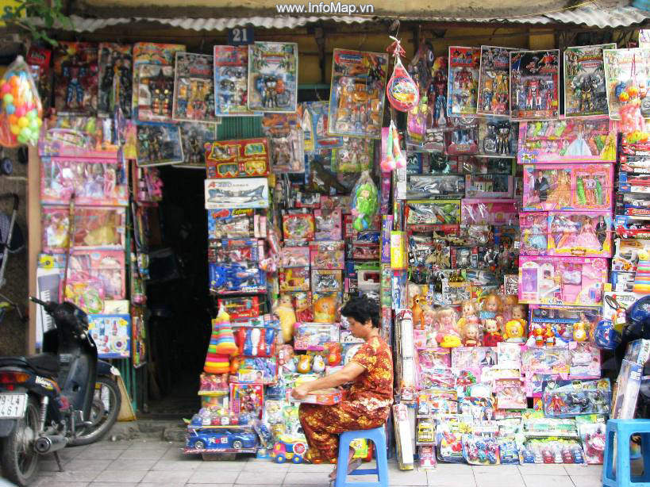

There are millions of local stores like this in Vietnam (Small SMEs), if we can help them sell more, we will change the game.

**The Culture, it is the biggest challenge for eCommerce?**

The Vietnamese Culture is the biggest challenge for eCommerce even I have lived in the U.S and using online shopping more than 6 years ago. Back there in Vietnam, I have used 5giay.vn a lot for C2C and meetup for payment. C2C on 5giay.vn is also means I trade with another S SMEs, or individual sellers on 5giay.vn. There are a lot of individual sellers on Vietnam’s C2C marketplace. They don’t have a real legit business, but they have online store to resell items they bought from the wholesellers (Wholesellers usually from the border of VN and China, Cambodia, Thailand or Wholesale Market). Example: <https://www.5giay.vn/threads/dong-ho-nam-sieu-dang-cap-phai-manh.8096902/>

Back to the Culture, The Vietnamese’s culture is go out and shop. If eCommerce business would like to change this, they should wait maybe 40 years. The reason is they have so many options available surrounding them so why they have to go online. The millions of option here is the Local S SME stores (Let’s forget about the Mall, the Mall is for middle class and higher). And, I think some of the SEA Countries is similar.

**Summary:**

There are a lot of people are talking about eCommerce of Vietnam; however, they don’t accept the real situation that the S SME is the BIGGEST barrier for eCommerce to evolve in Vietnam. And, if they build something which people don’t need, then nobody gonna use it like B2C and Grocery shopping online. It is Vietnam, it is not Singapore, U.S or Europe. The Vietnamese **Culture** is different; therefore, something works in the U.S or other countries, it can’t be applied in VN.

B2C is even facing a tougher challenge than C2C. In C2C, the S SME can sell their items on the platform just like TaoBao and delivery themselves or using whatever services they want, even TaoBao’s logistic’s partners. If they work with Adayroi or Lazada, they have to grow bigger size to become an enterprise which has accountants, logistic services or paying for a 3rd-party service like GHN.

The picture below: I am asking my friend to try Adayroi, she lives right in district 1 of HCMC and currently a junior in College. She said, she can deal with the seller for price if she goes out to shop, she can’t deal for the price online like Adayroi and Lazada. And, the shipping fee, she does not want to pay for shipping since she can just stop by the grocery store to buy fresh vegetable or stuffs which she can physically test.



All the startup ideas like Peer to Peer Grocery Shopping (Ahamove, RedMart), traditional B2C (Lazada, Adayroi, Tiki...) sounds great. However, it is not for Vietnam currently and even the next 15 years. Note: Fashion and Shoes is exceptional for B2C (Zalora) because Vietnamese consumers can find something which they can’t at the local stores.

Finally, to solve the culture problem, I think we should adapt to go with customer’s needs instead of trying to change them to U.S’s customers. They need time to adapt, we can’t throw an Amazon model to Vietnam and expect them to change within a short time. Currently, the million of local stores or S SME i have mentioned above are everywhere on streets, they are even next to each others and selling the same items or even stores on the entire street sells the same thing.

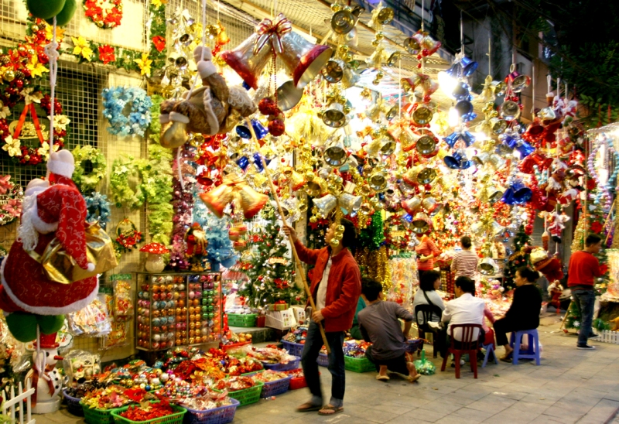

It is really really competitive. **It should be a better way to help them to sell easier, and to help the consumers find them easier instead of go around and ask.** For the Online C2C retailers, individual sellers, there are a lot of barriers. C2C (SME, S SME, individual sellers, used items) in Vietnam usually happens in local trading, on social media sites, or old-fashion C2C marketplace. **It should be a better way to help them trade from anywhere, easier, search items from any places regardless of distance. It should be a better way for the buyers to talk to the sellers, deal for better price and less shipping fee.**